**College of Engineering**

**Diversity and Inclusion**

**Demographic Data Update**

**Fall 2021**

**Ken Bright, Academic Analyst**

**College of Engineering**

**December 3, 2021**

**Table of Contents**

Summary assessment of progress towards five-year goals 1

Highlights 2

1. Introduction 4
2. Faculty data
   1. Overview 5
   2. Gender 6
   3. Underrepresented Status 9
3. Staff data
   1. Gender 12
   2. Underrepresented Status 13
4. Graduate student data
   1. Overview 14
   2. Gender 15
   3. Underrepresented Status 18
5. Undergraduate student data
   1. Overview 21
   2. Gender 22
   3. Underrepresented Status 26
   4. Retention 30

Appendix A. Definitions 31

Appendix B. Fall 2021 Raw data for COE Faculty, Staff & Students 33

Appendix C. Historical Raw data for COE Faculty, Staff & Students 41

**Summary assessment of progress towards five-year goals**

The five-year goals for 2017-2022 defined in the College of Engineering Strategic Plan for Diversity and Inclusion are shown, followed by a summary assessment of the current status after one year. Green shading indicates a target goal has been met. Appendix A defines the department and program acronyms.

|  |  |  |  |  |  |  |  |  |  |  |  |  |  |  |  |  |  |  |  |  |
| --- | --- | --- | --- | --- | --- | --- | --- | --- | --- | --- | --- | --- | --- | --- | --- | --- | --- | --- | --- | --- |
| **FIVE-YEAR GOALS**   |  |  |  |  | | --- | --- | --- | --- | |  | Demographics  for each department and  for the College as a whole | Disparities (racial, gender)  for the College as a whole | Climate | | Faculty | 25% women  10% URGs | * No disparities in retention rates * Continuous improvement towards no disparities in T/TT vs. CT, and in distribution across ranks | Inclusive, supportive | | Graduate students | Among incoming students:  33% women  25% URGs (among domestic) | No disparities in retention rates | Inclusive, supportive | | Undergraduate students | Among incoming students:  30% women  15% URGs | No disparities in 6-year graduation rates (70% for all) | Inclusive, supportive | | Staff | 30% women on technical staff  20% URGs on all staff  20% men on administrative staff | Continuous improvement towards no disparities in managerial vs. non-managerial | Inclusive, supportive | |

*T/TT = Tenured/tenure-track. CT=Continuing track. URG=From underrepresented group (i.e., non-White, non-Asian)







**Highlights**

**Faculty**

Gender

* College is just short of target at 24%, unchanged from prior 2 years. (Fig. 3)
* 3 of 7 departments are meeting the 25% target while 1 other is at 24%. (Fig. 4)
* The College is in the top 31st percentile of all U.S. colleges of engineering in terms of percentage of women T/TT faculty, down 7 points from a year earlier. (Table 1)
* Two departments (CISC and MSEG) are in the top 23rd percentile of all U.S. colleges of engineering in terms of percentage of women T/TT faculty. (Table 1)
* ELEG is the only department without a women full professor. (Fig. 5)
* All departments have at least five women faculty. (Fig. 6)

URG

* The College increased slightly to 7% URG faculty, up 1 point from last year. (Fig. 3)
* 2 of 7 departments have exceeded the 10% target (CHEG and MSEG). (Fig. 7)
* BMEG and CISC have no URG faculty. (Fig. 8)
* The College is in the top 36th percentile of all U.S. colleges of engineering in terms of percentage of URG TT/T faculty, down 10 points from the prior year. (Table 2)
* Three departments (CHEG, ELEG and MSEG) are in the top 25th percentile of all U.S colleges of engineering in terms of percentage of URG TT/T faculty. (Table 2)
* All but one URG faculty in the College are tenured or tenure-track. (Fig. 8)

**Staff**

* The percentage of women in research and technical support positions has risen in each of the last two years (Fig. 10)
* The percentage of women on the College staff decreased by two points while the percentage of women in managerial roles increased by one point from last year (Fig. 10,11)
* The percentage of URG College staff fell to 9% and remains far short of 20% target. (Fig.12)
* The percentage of URG College staff in managerial roles reached 14%, up from 9% two years earlier. (Fig. 13)

**Graduate students**

Gender

* The percentage of all graduate students who are women remained flat at 29%. (Fig. 15)
* Women comprised 29% of incoming graduate students, against a target of 33%. (Fig. 16)
* 3 of 7 departments (BMEG, CISC and MSEG) met the 33% target for incoming students. (Fig. 16)
* The College is in the 67th percentile of all U.S. colleges of engineering in terms of percentage of women graduate students, up 6 points from prior year. (Table 3).
* BMEG, CIEG and MSEG are in the top third percentile of all U.S. colleges of engineering in terms of percentage of women graduate students. (Table 3)

**Graduate students (cont.)**

URG

* The % of URG domestic graduate students in the College increased slightly from last year. (Fig. 15)
* 3 of 7 departments exceeded the 25% target for incoming URG domestic students (CIEG, CISC and ELEG). (Fig. 19)
* BMEG and MSEG had no incoming URG domestic graduate students. (Fig. 19).
* The percentile ranking of the College in terms of the % of URG domestic graduate students fell for the third straight year. (Table 4)

**Undergraduate students**

Gender

* The % of women undergraduate students in the College reached a 10-year high of 29%. (Fig. 23)
* The College exceeded the 30% target for incoming women undergraduate students in 2021. (Fig. 24)
* 5 of 11 programs met or exceeded the 30% target for incoming women undergraduate students. (Fig. 24)
* The College is in the 79th percentile of all U.S. colleges of engineering in terms of percentage of women undergraduates, up 4 points from one year ago. (Table 5)
* 4 programs (BMEG, CISC, ENEG and MSEG) are in the top third percentile of all U.S. colleges of engineering in terms of percentage of women undergraduate students. (Table 5)
* Chemical & Electrical Engineering ranked in the bottom 20th percentile of all U.S. colleges of engineering in terms of percentage of women undergraduate students. (Table 5)
* The most recent six-year graduation rate within original major for women in the College is 56%, compared to 63% for majority students. (Fig. 30)

URG

* The percentage of undergraduate URG students in the College remained flat at 15%. (Fig. 23)
* The College exceeded the 15% target for incoming undergraduate URG students by three points in 2021. (Fig. 27)
* 7 of 11 programs met or exceeded the 15% target for incoming URG undergraduate students. (Fig. 27)
* The College remains below the median among all U.S. colleges of engineering in terms of percentage of undergraduate URG students. (Table 6)
* The most recent six-year graduation rate within original major for undergraduate URG students in the College is 49%, compared to 63% for majority students. (Fig. 30)

**1. Introduction**

During 2017, an initiative was undertaken by groups of COE stakeholders to define quantifiable demographic targets for the COE in order to achieve inclusive excellence across four constituent groups—faculty, staff, graduate students, and undergraduate students. Five-year goals were identified and presented in the resulting *College of Engineering Strategic Plan for Diversity and Inclusion* available at <https://www.engr.edu/initiatives/diversity-inclusion> (Figure 1).

|  |  |  |  |  |  |  |  |  |  |  |  |  |  |  |  |  |  |  |  |  |
| --- | --- | --- | --- | --- | --- | --- | --- | --- | --- | --- | --- | --- | --- | --- | --- | --- | --- | --- | --- | --- |
| **FIVE-YEAR GOALS**   |  |  |  |  | | --- | --- | --- | --- | |  | Demographics  for each department and  for the College as a whole | Disparities (racial, gender)  for the College as a whole | Climate | | Faculty | 25% women  10% URGs | * No disparities in retention rates * Continuous improvement towards no disparities in T/TT vs. CT, and in distribution across ranks | Inclusive, supportive | | Graduate students | Among incoming students:  33% women  25% URGs (among domestic) | No disparities in retention rates | Inclusive, supportive | | Undergraduate students | Among incoming students:  30% women  15% URGs | No disparities in 6-year graduation rates (70% for all) | Inclusive, supportive | | Staff | 30% women on technical staff  20% URGs on all staff  20% men on administrative staff | Continuous improvement towards no disparities in managerial vs. non-managerial | Inclusive, supportive | |

*T/TT = Tenured/tenure-track. CT=Continuing track. URG=From underrepresented group (i.e., non-White, non-Asian)

Figure 1. Five-year goals for College diversity and inclusion

In conjunction with the Strategic Plan, an addendum report of summarized metrics was prepared in September 2017 to measure the current state of the COE with respect to those five-year goals and provide historical context. This report is the fourth in a series of annual updates to those September 2017 figures, which ongoing will be produced each Fall to assess progress and provide insights on this initiative.

The report is comprised of both current measures for the College of Engineering, and historical comparative data for the COE and other U.S. Engineering schools. For each of the constituent groups, current data as of Fall 2021 was derived from UD internal sources. For the faculty and student populations, the historical comparative measures were based on data from the American Society for Engineering Education (ASEE). For staff, comparative statistics were drawn from the U.S. Census Bureau. Similar to the Sept 2017 report, although the College values and seeks diversity in all respects, metrics here focus on diversity with respect to women and underrepresented groups (defined in engineering as non-White, non-Asian).

Owing to limitations in the ASEE data, comparative measures for faculty only consider tenured/tenure-track (T/TT) faculty, not continuing track (CT) faculty. Comparative metrics include comparisons to all institutions in the ASEE database, as well as the 25-school comparative set defined by the University (Appendix A).

**2. Faculty Data**

**2.1 Overview**

Notes for faculty data:

* Only faculty with primary appointments with COE are considered.
* Includes faculty with administrative appointments in their home departments, except the Dean who is not included as faculty (consistent with UD records).
* Does not include non-COE faculty with secondary appointments with COE, Non-Tenure Temporary Faculty (i.e., Research Faculty), or faculty on non-paid leave of absence.
* URG status (non-white, non-Asian) was determined from the faculty member’s Primary Ethnicity
* In the comparison with other universities, for college-level data over time, for each school, we sum only students in the same departments/programs we have in UD COE.
* Department acronyms are defined in Appendix A.

Figure 2 presents the number of women, URG and total (T/TT and CT) faculty for the College of Engineering over the last 5 years.

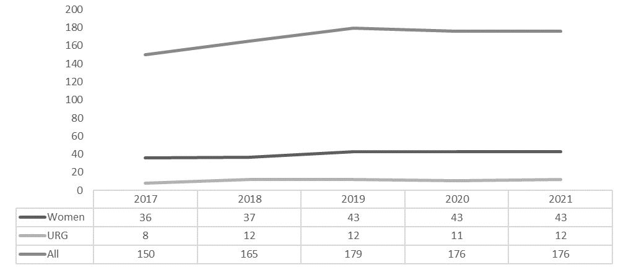

Figure 2. No. of Women, URG and All Faculty, T/TT and CT, COE, prior 5 years (2017-2021)

Figure 3 presents the percentage of women and URG faculty for the College of Engineering over the last 5 years.

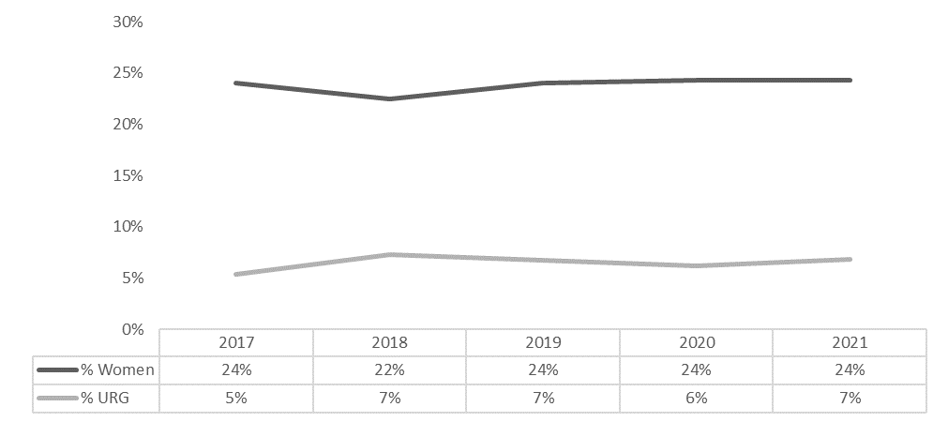

Figure 3. % Women and URG faculty, COE, prior 5 years (2017-2021)

**2.2 Gender**

Figure 4 summarizes the percentage of women faculty in the College of Engineering as of Fall 2021 by job rank and title. Figure 5 presents the actual number of women faculty by job rank and title at the department level. In both cases T/TT and CT faculty are included, as this data is available within UD sources.

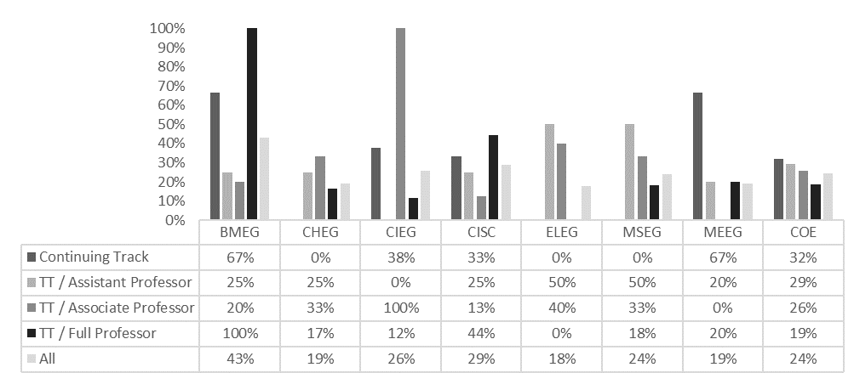

Figure 4. % Women T/TT and CT faculty by department and for the COE, by job rank and type, Fall 2021

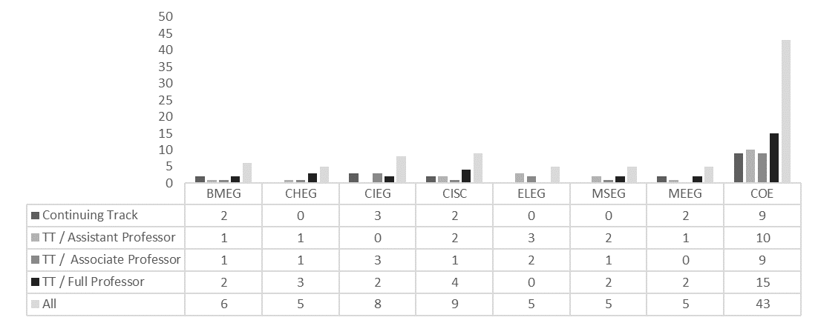 Figure 5. No. of Women T/TT and CT faculty by department and for the COE, by job rank and type, Fall 2021

Figure 6 illustrates the change by department in the number of TT/T and CT women faculty at the College of Engineering over the last 5 years.

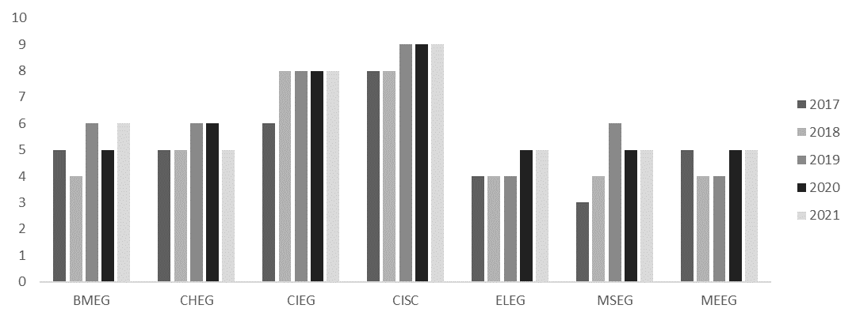

Figure 6. No. of Women TT/T and CT faculty, by COE department, prior 5 years (2017-2021)

Comparative data for women faculty over the last 10 years for the COE and other ASEE-tracked institutions can be found in Table 1. Faculty data in this case only includes T/TT faculty. Data is presented for both comparative sets, and detail on rankings including percentile have been provided.

Table 1. % Women faculty for the COE, by department, T/TT only, prior 10 years (2011-2020)



**2.3 Underrepresented Status**

Figure 7 summarizes the percentage of faculty from underrepresented groups (URG) in the College of Engineering as of Fall 2021 by job rank and title. Figure 8 presents the actual number of URG faculty by job rank and title at the department level. In both cases T/TT and CT faculty are included.

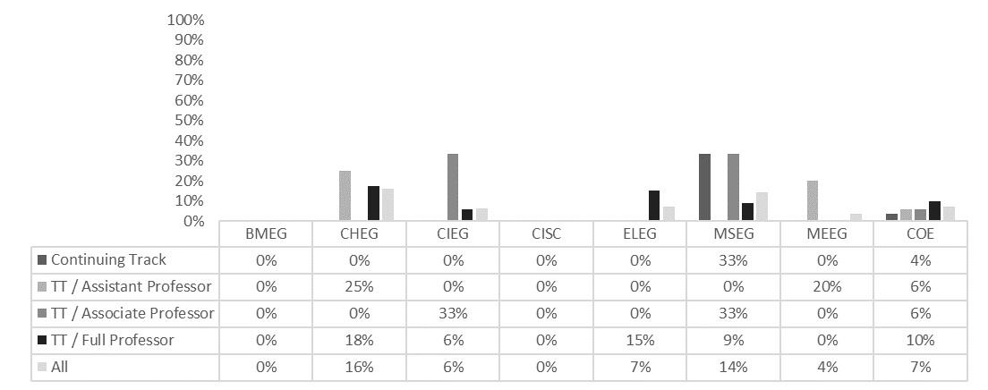

Figure 7. % URG T/TT and CT faculty by department and for the COE, by job rank and type, Fall 2021

Figure 8. No. of URG T/TT and CT faculty by department and for the COE, by job rank and type, Fall 2021

Figure 9 illustrates the change by department in the number of URG TT/T and CT faculty at the College of Engineering over the last 5 years.

Figure 9. No. of URG TT/T and CT faculty, by COE department, prior 5 years (2017-2021)

Comparative URG faculty data over the last 10 years for the COE and other ASEE-tracked institutions can be found in Table 2. Faculty data in this case only includes T/TT faculty. Data is presented for both comparative sets, and detail on rankings including percentile have been provided.

Table 2. % URG faculty for the COE, by department, T/TT only, over last 10 years (2011-2020)



**3. Staff Data**

**3.1 Gender**

Figure 10 reflects the % of female COE staff by job type over the last four years. Comparative data for New Castle County is as of July 2019. Figure 11 shows the % of female COE staff by managerial role and does not include research staff. The categorical definitions for each job type (admin, research and tech) can be found in the Appendix A.

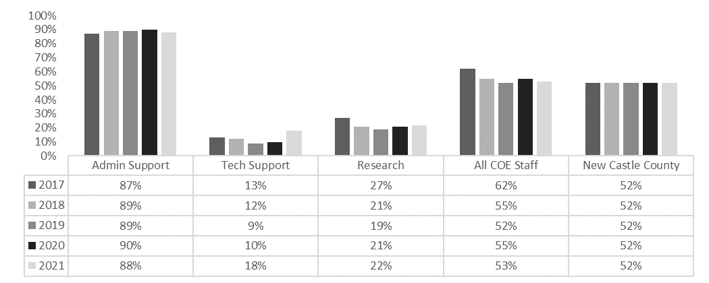

Figure 10. % Women College of Engineering administrative, technical and research support staff

data by job type, Fall 2017 to Fall 2021

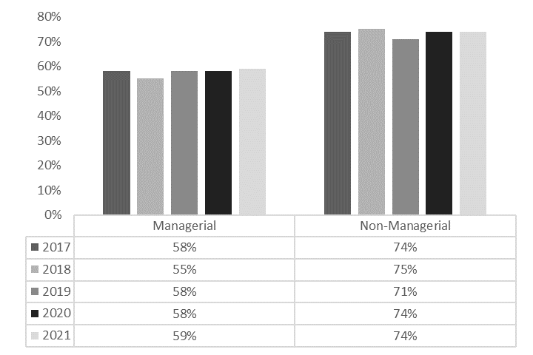

Figure 11. % Women College of Engineering administrative and technical support staff data

by managerial role, Fall 2017 to Fall 2021

**3.2 Underrepresented Status**

Figure 12 reflects the breakdown of COE staff by job type and underrepresented status over the last three years. Comparative data for New Castle County is as of July 2019. Figure 13 shows the gender breakdown by managerial role and does not include research staff. URG (non-white, non-Asian) status is determined from a staff member’s Primary Ethnicity.

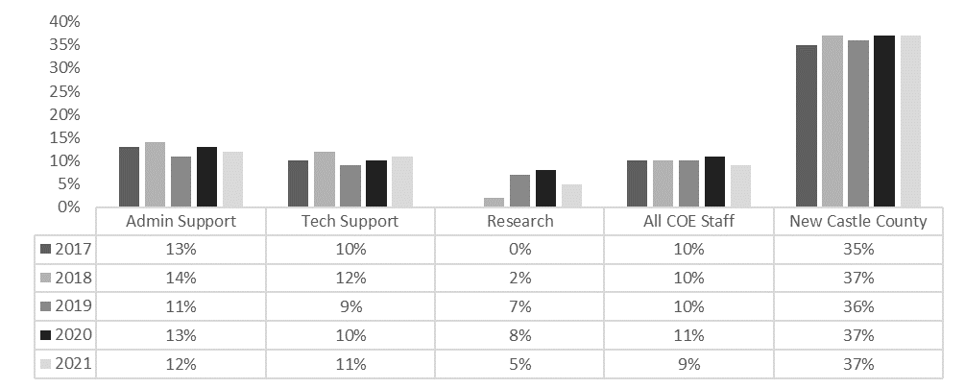

Figure 12. % URG College of Engineering administrative, technical and research support staff data by job type and URG status, Fall 2017 to Fall 2021

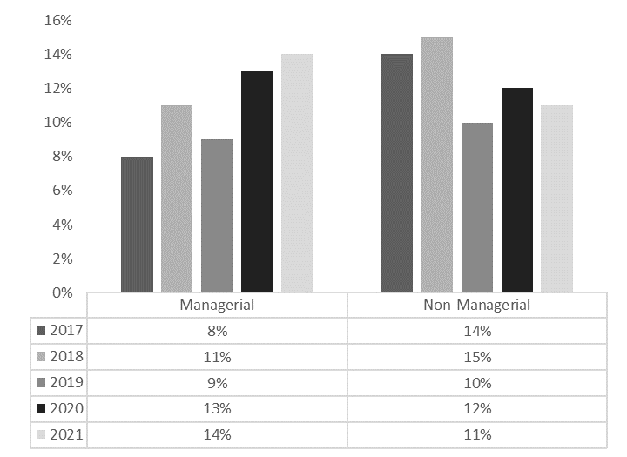

Figure 13. College of Engineering administrative and technical support staff data by managerial

role and URG status, Fall 2017 to Fall 2021

**4. Graduate Student Data**

**4.1 Overview**

Notes for graduate student data:

* URG = all non-White, Non-Asian students + ½ of students indicating two or more races; determined from IPEDS Ethnicity
* % URG = Num. **domestic** URG / Num. **domestic** students
* In using ASEE data for other universities for comparison,
  + All students in civil, environmental, or civil/environmental were aggregated into CIEG.
  + All students in electrical, computer engineering, or electrical/computer engineering were aggregated into ELEG.
  + Students in Metallurgical and Materials Engineering were counted as MSEG.
  + All students in Computer Science, both inside and outside of engineering were aggregated as CISC.
  + For college-level data over time, for each school, we sum only students in the same departments/programs we have in UD COE.

Figure 14 presents the number of women, domestic URG and total Graduate students at the College of Engineering over the last 10 years

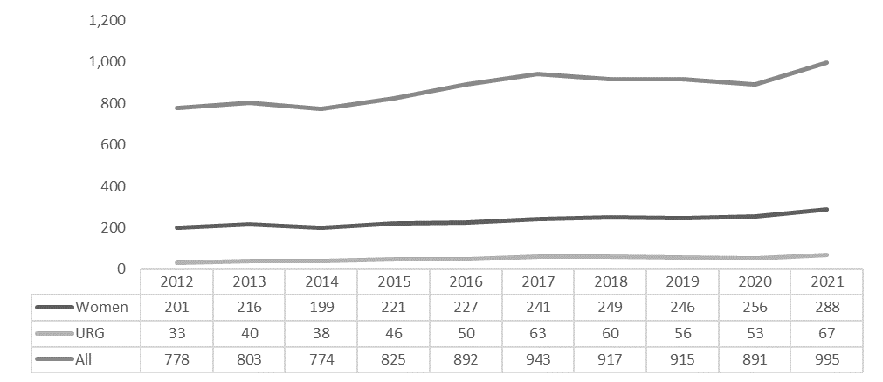

Figure 14. No. of Women, Domestic URG and All Graduate Students, COE, prior 10 years (2012-2021)

Figure 15 presents the percentage of women and domestic URG Graduate students at the College of Engineering over the last 10 years

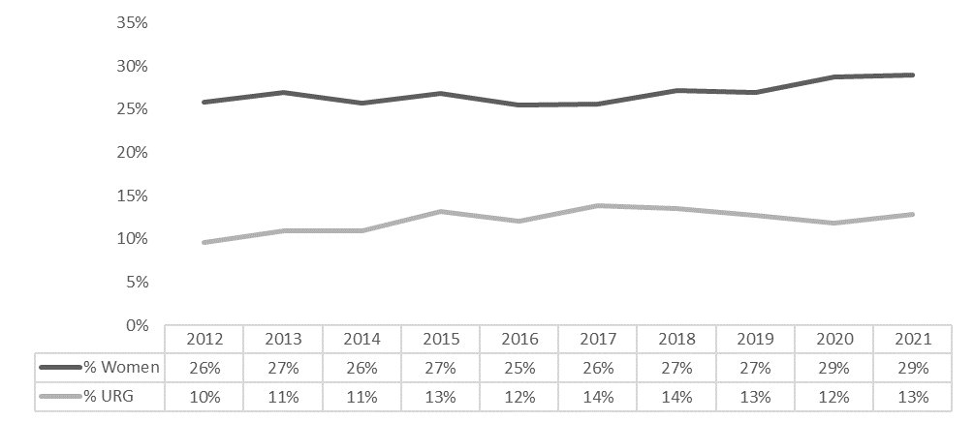

Figure 15. % Women and Domestic URG Graduate Students, COE, prior 10 years (2012-2021)

**4.2 Gender**

Figure 16 summarizes the percentage of women among all Graduate students and all incoming Graduate students as of Fall 2021 at the department level for the College of Engineering, and the % of graduating Women Graduate students for Academic Year 2020-21. Figure 17 shows the same data in absolute numbers.

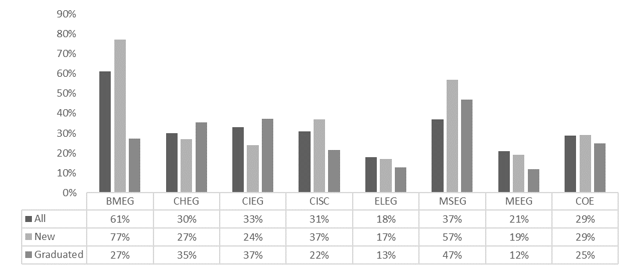

Figure 16. % of Women Graduate Students, All and New, by COE department, Fall 2021 and % of graduating Women Graduate Students by department, Academic Year 20-21

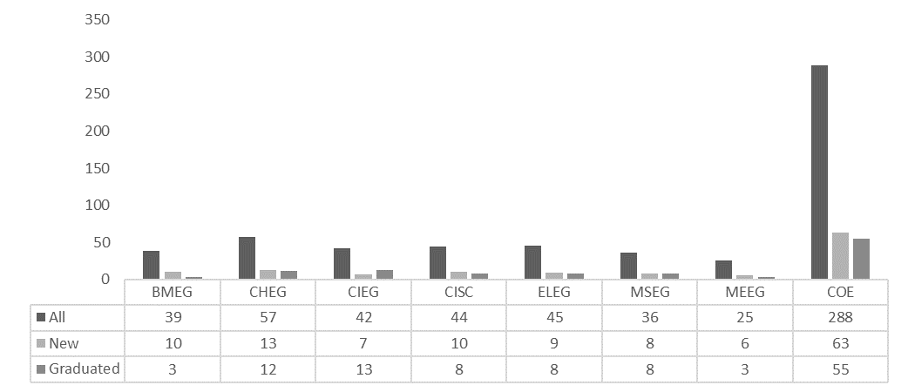

Figure 17. No. of Women Graduate Students, All and New, by COE department, Fall 2021 and No. of graduating Women Graduate Students by department, Academic Year 20-21

Figure 18 illustrates the change by department in the number of Women Graduate students at the College of Engineering over the last 10 years.

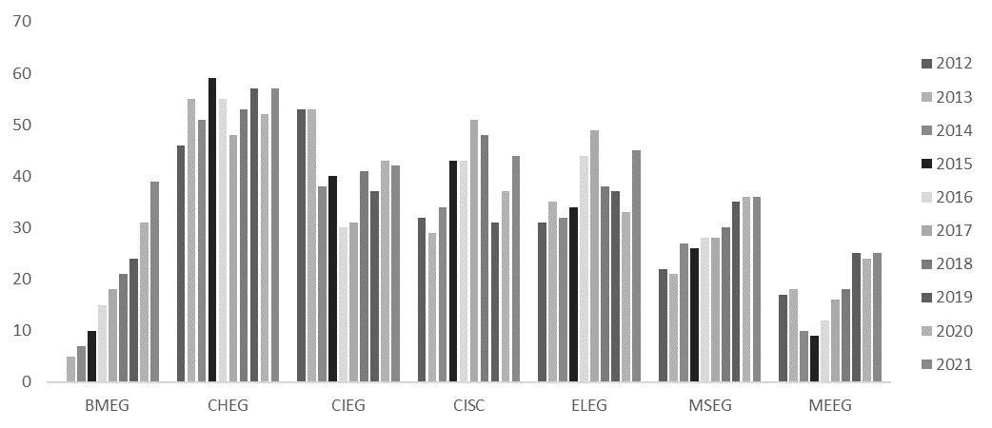

Figure 18. No. of Women Graduate students, by COE department, prior the last 10 years (2012-2021)

Comparative data for Women Graduate students over the last 10 years for the COE and other ASEE-tracked institutions can be found in Table 3. The ASEE was unable to provide Fall 2020 metrics for comparison for Materials Science.

Table 3. % Women Graduate Students for the COE, by department, over last 10 years (2011-2020)



**4.3 Underrepresented Status**

Figure 19 summarizes the percentage of URG students among all Graduate students and all incoming Graduate students as of Fall 2021 at the department level for the College of Engineering, and the % of graduating URG Graduate students for Academic Year 2020-21. Figure 20 shows the same data in absolute numbers.

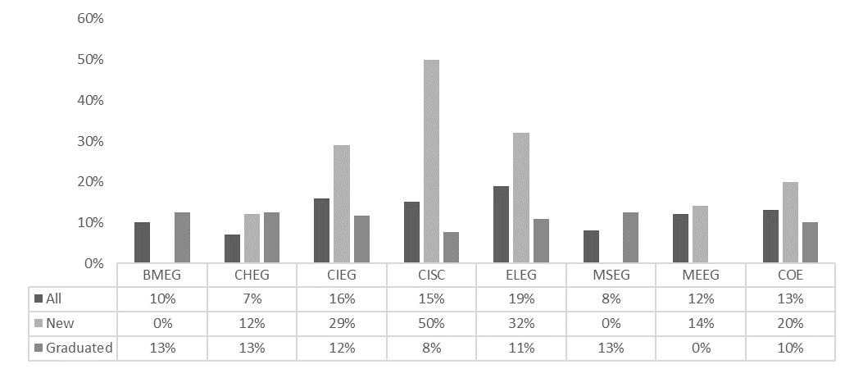

Figure 19. % of URG Graduate Students, All and New, by COE department, Fall 2021 and % of graduating URG Graduate Students by department, Academic Year 20-21

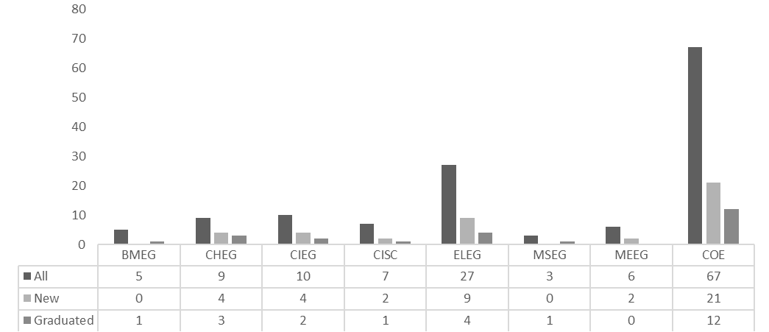

Figure 20. No. of URG Graduate Students, All and New, by COE department, Fall 2021 and No. of graduating URG Graduate Students by department, Academic Year 20-21

Figure 21 illustrates the change by department in the number of URG Graduate students at the College of Engineering over the last 10 years.

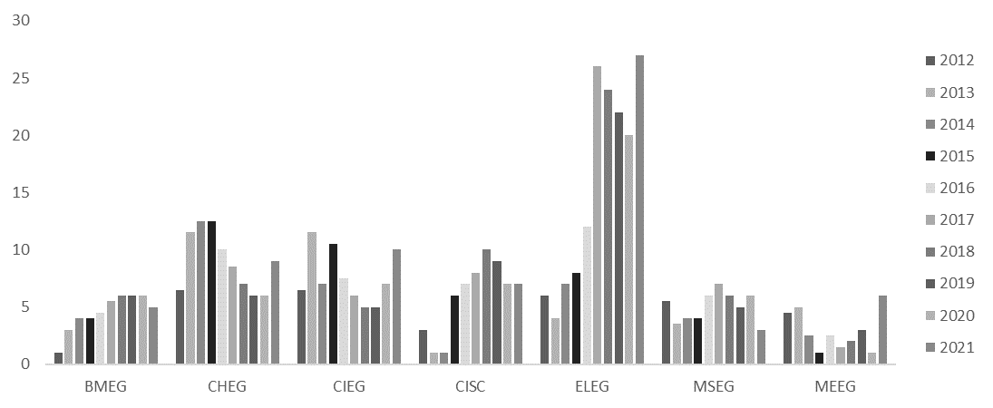

Figure 21. No. of URG Graduate students, by COE department, prior 10 years (2012-2021)

Comparative data for URG Graduate students over the last 10 years for the COE and other ASEE-tracked institutions can be found in Table 4. The ASEE was unable to provide Fall 2020 metrics for comparison for Materials Science.

Table 4. % URG Graduate Students for the COE, by department, over last 10 years (2011-2020)



**5. Undergraduate Student Data**

**5.1 Overview**

Notes on undergraduate student data

* URG = all non-White, Non-Asian students + ½ of students indicating two or more races; determined from IPEDS Ethnicity
* % URG = Num. URG / All students
* Data for student was computed for each engineering program, not department: biomedical engineering, chemical engineering, civil engineering, computer science, computer engineering, construction management, electrical engineering, environmental engineering, material sciences, mechanical engineering and engineering undeclared (see relationship between departments and programs in Appendix A).
* In using ASEE data for other universities for comparison,
  + For Computer Science, all BA and BS programs were aggregated.
  + For college-level data over time, for each school, we sum only students in the same departments/programs we have in UD COE.
  + Comparative metrics are not available for engineering undeclared programs. Figures are not shown for construction management and materials science programs owing to small numbers of students in these recently-added UD COE offerings.

Figure 22 presents the number of women, URG and total Undergraduate students at the College of Engineering over the last 10 years.

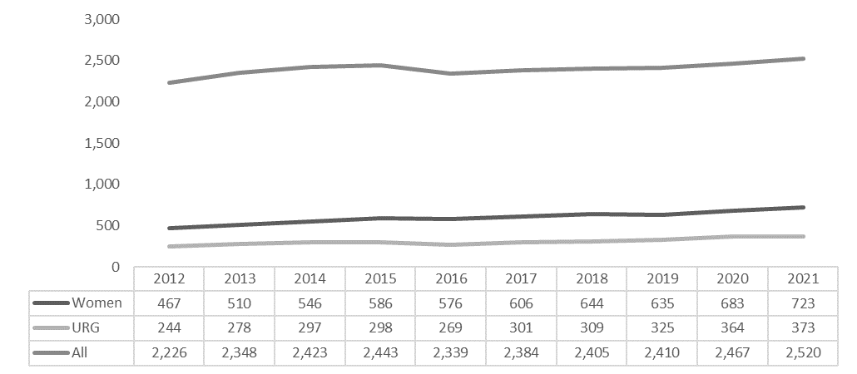

Figure 22. No. of Women, URG and All Undergraduate Students, COE, prior 10 years (2012-2021)

Figure 23 presents the % of women, URG and total Undergraduate students at the College of Engineering over the last 10 years.

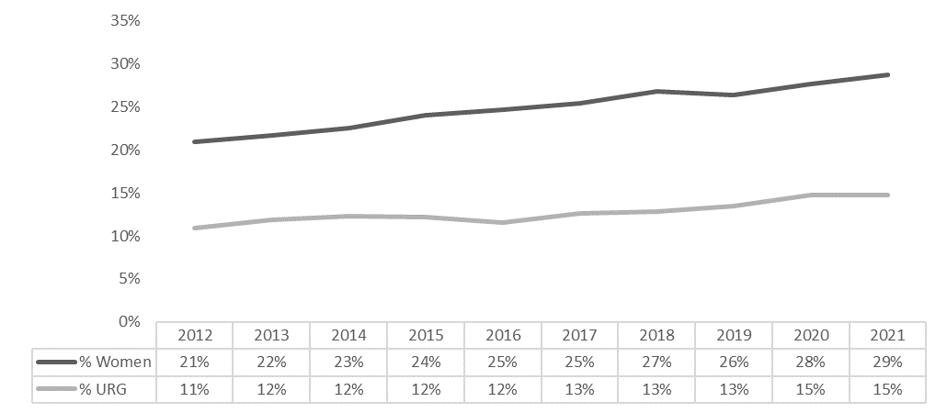

Figure 23. %. of Women, and URG Undergraduate Students, COE, prior 10 years (2012-2021)

**5.2 Gender**

Figure 24 summarizes the percentage of women among all Undergraduate students and all incoming Undergraduate students as of Fall 2021 at the program level for the College of Engineering, and the % of graduating Women Undergraduate students for Academic Year 2020-21. Figure 25 shows the same data in absolute numbers. **Note** – Students cannot graduate from engineering undeclared program; materials science program is less than 4 years old.

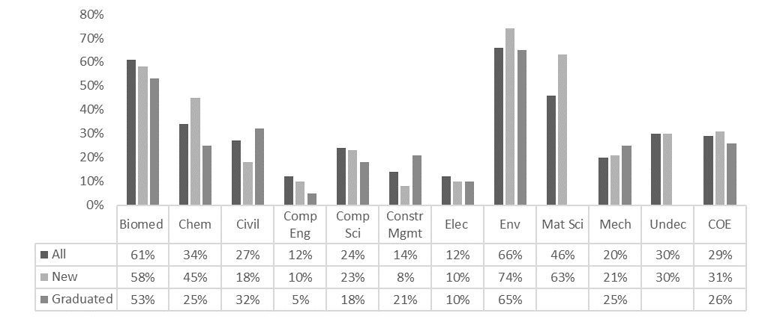

Figure 24. % of Women Undergraduate Students, All and New, by COE department, Fall 2021 and % of graduating Women Undergraduate Students by program, Academic Year 20-21

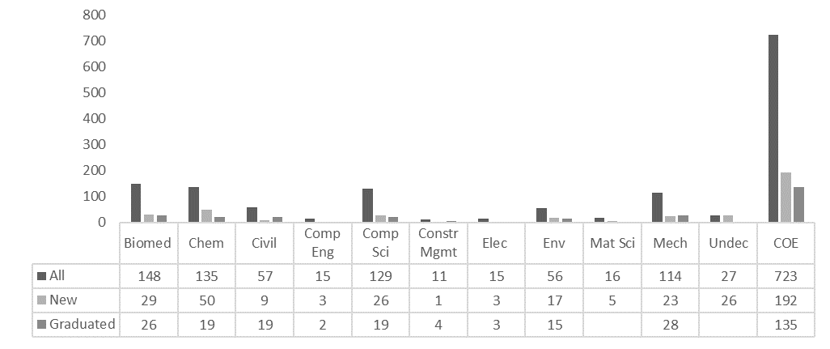

Figure 25. No. of Women Undergraduate Students, All and New, by COE department, Fall 2021 and No. of graduating Women Undergraduate Students by program, Academic Year 20-21

Figure 26 illustrates the change by program in the number of Women Undergraduate students at the College of Engineering over the last 10 years.

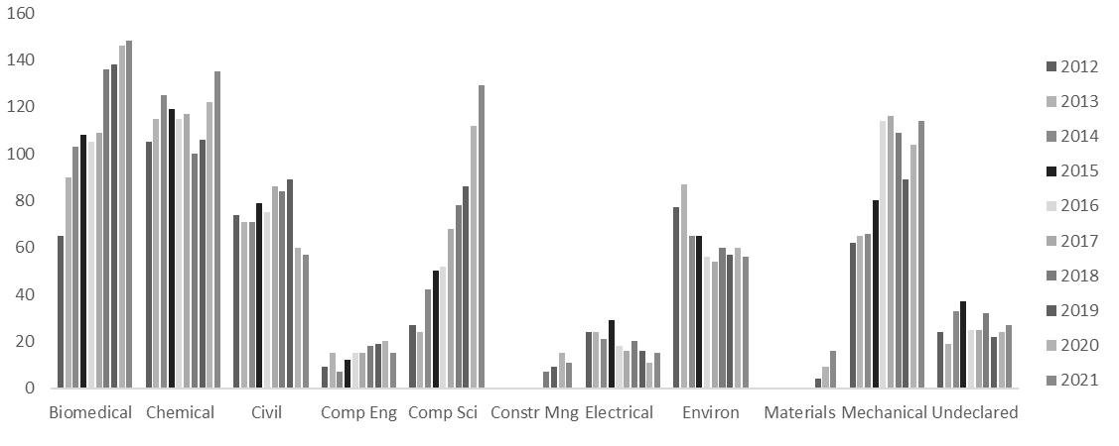

Figure 26. No. of Women Undergraduate students, by COE program, prior 10 years (2012-2021)

Comparative data for Women Undergraduate students over the last 10 years for the COE and other ASEE-tracked institutions can be found in Table 5.

Table 5. % Women Undergraduate Students for the COE, by program, last 10 years (2010-2019)



Table 5. % Women Undergraduate Students for the COE, by program, last 10 years (2011-2020) (cont.)



**5.3 Underrepresented Status**

Figure 27 summarizes the percentage of URG students among all Undergraduate students and all incoming Undergraduate students as of Fall 2021 at the program level for the College of Engineering, and the % of graduating URG Undergraduate students for Academic Year 2020-21. Figure 28 shows the same data in absolute numbers. **Note** – Students cannot graduate from engineering undeclared program; materials science program is less than 4 years old.

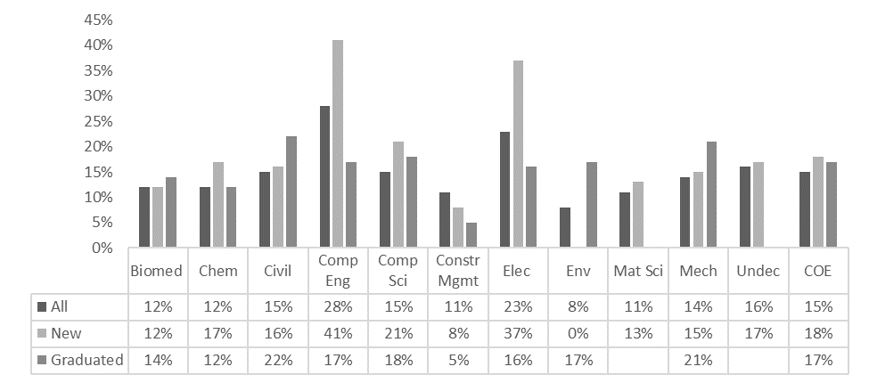

Figure 27. % of URG Undergraduate Students, All and New, by COE department, Fall 2021 and % of graduating URG Undergraduate Students by program, Academic Year 20-21

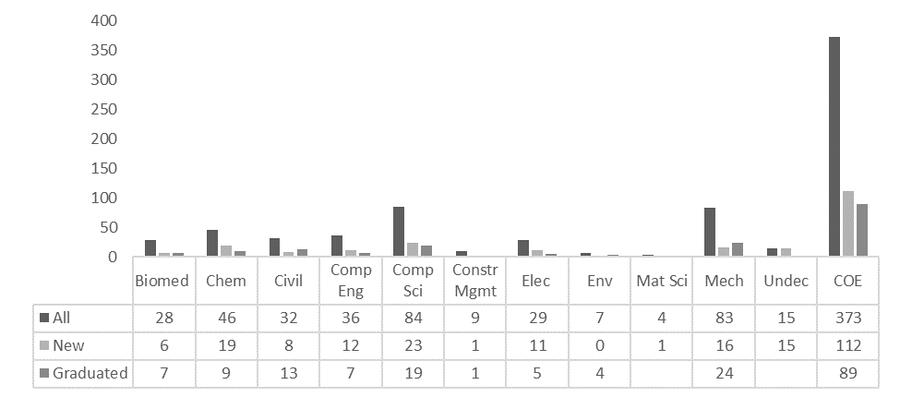

Figure 28. No. of URG Undergraduate Students, All and New, by COE department, Fall 2021 and No. of graduating URG Undergraduate Students by program, Academic Year 20-21

Figure 29 illustrates the change by program in the number of URG Undergraduate students at the College of Engineering over the last 10 years.

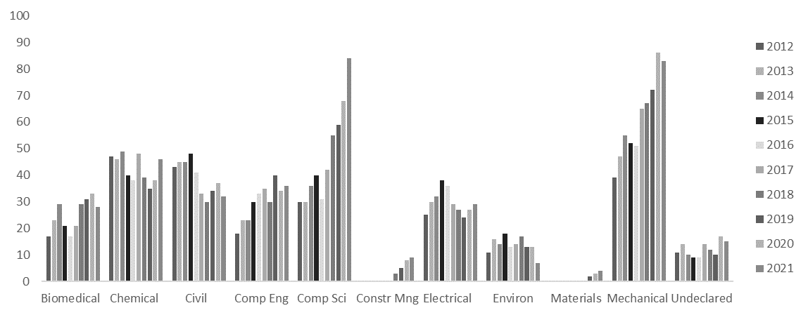

Figure 29. No. of URG Undergraduate students, by COE program, prior 10 years (2012-2021)

Comparative data for URG Undergraduate students over the last 10 years for the COE and other ASEE-tracked institutions can be found in Table 6.

Table 6. % URG Undergraduate Students for the COE, by program, last 10 years (2011-2020)



Table 6. % URG Undergraduate Students for the COE, by program, last 10 years (2011-2020) (cont.)



**5.4 Retention**

Figure 30 summarizes the 6-year graduation rates for Undergraduate students by program for majority, minority, and female populations in the Fall 2015 cohort. Graduation rates shown are for students who graduate in their original COE program.

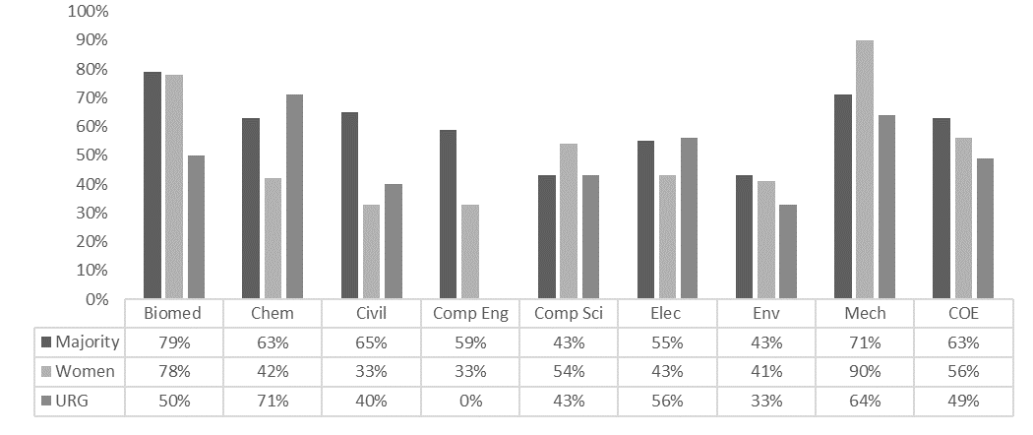

Figure 30. Retention rates, Fall 2015 cohort, quantified by 6-year graduation rates, for all COE undergraduate programs

**Appendix A - Definitions**

**University of Delaware Comparator Institutions (as of September 2016**)

1. Boston University
2. Case Western Reserve University
3. Georgia Institute of Technology – Main Campus
4. Indiana University – Bloomington
5. Iowa State University
6. Michigan State University
7. North Carolina State University at Raleigh
8. Ohio State University – Main Campus
9. Pennsylvania State University – Main Campus
10. Purdue University – Main Campus
11. Rutgers University – New Brunswick
12. Stony Brook University
13. Texas A&M University – College Station
14. University of Arizona
15. University of Connecticut
16. University of Illinois at Urbana-Champaign
17. University of Maryland – College Park
18. University of Massachusetts – Amherst
19. University of Michigan – Ann Arbor
20. University of Minnesota – Twin Cities
21. University of North Carolina at Chapel Hill
22. University of Pittsburgh
23. University of Utah
24. University of Virginia – Main Campus
25. Virginia Polytechnic Institute and State University

**Departments and undergraduate programs**

COE = College of Engineering

|  |  |  |
| --- | --- | --- |
|  | Department | Undergraduate program(s) |
| BMEG | Biomedical engineering | Biomedical engineering |
| CHEG | Chemical and biomolecular engineering | Chemical engineering |
| CIEG | Civil and environmental engineering | Civil engineering  Construction engineering and management  Environmental engineering |
| CISC | Computer science | Computer science  Information systems |
| ELEG | Electrical and computer engineering | Computer engineering  Electrical engineering |
| MSEG | Materials science and engineering | Materials science and engineering |
| MEEG | Mechanical engineering | Mechanical engineering |

Figures for all undergraduate computer science programs (BA and BS) have been combined into one due to low numbers of students in two of the three programs.

**Staff Job Types**

Table A1. Job titles included in each job type

|  |  |
| --- | --- |
| **Job type** | **Jobs included** |
| Administrative support | Human resources staff, department support staff (administrative assistants, academic advisors, business administrators), sponsored research and procurement staff, outreach, Dean’s support staff, financial services, academic affairs, communications |
| Technical support | Facilities, lab coordinators, core facilities (machine shops, electronics), information technology |
| Research staff | Lab and center researchers (Engineers), limited-term researchers |

**Appendix B – Raw Data, Fall 2021, for Faculty, Staff & Students**

Table B1. Fall 2021 Faculty by department, type/rank, and gender



Table B2. Fall 2021 Faculty by department, type/rank, and race



Table B3. Fall 2021 COE Staff by job type, gender, and race



Table B4. Fall 2021 COE administrative and technical staff (no research staff) by managerial role, gender, and race



Table B5. All Fall 2021 COE Graduate Students by department, gender, and race



Table B6. New Fall 2021 COE Graduate Students by department, gender, and race



Table B7. AY 20-21 graduating COE Graduate Students by department, gender, and race



Table B8. All Fall 2021 COE Undergraduate Students by program, gender, and race



Table B9. New Fall 2021 COE Undergraduate Students by program, gender, and race



Table B10. AY 20-21 graduating COE Undergraduate Students by program, gender, and race



**Appendix C – Raw Data, Historical, for Faculty, Staff & Students**

Table C1. 10 Year (2012-2021) COE Undergraduate Students by program, gender and URG status



Table C2. 10 Year (2012-2021) COE Graduate Students by department, gender and URG status



Table C3. 10 Year (2012-2021) COE Faculty by department, type, gender and URG status



*Data are not available for shaded cells*

Table C3. 10 Year (2012-2021) COE Faculty by department, type, gender and URG status (cont.)



*Data are not available for shaded cells*

Table C4. 4 Year (2017-2021) COE Staff by job type, managerial role, gender and URG status

